Mary Anderson  
Text Mining Acquire & Analyze  
November 8, 2020

**Repository Link:** <https://github.com/maryeand/TM_Twitter_McConnell-McGrath>

**Dataset information (summarized from data set share):**

This data is from Twitter. I was interested in the recent Kentucky senate race between Mitch McConnell and Amy McGrath. Mitch McConnell is a Republican and the current Senate Majority Leader. Amy McGrath unsuccessfully ran against him as a Democrat. I am interested in this specific Senate race as Mitch McConnell has held this seat since 1985 and his role as Senate Majority Leader is a significant and important role. McConnell and McGrath vary widely in their political beliefs.

**Data set description:**

This data was scraped from Twitter using Tweepy. The data is in two text files, one for McConnell and McGrath each. The information scraped includes the follower’s handle, location, follower count (how many people follow them), friend count (how many people they follow), and their profile description.

**Descriptive statistics:**

Size of Data: Two text files, one for McConnell (149 MB, 1,938,905 rows) and one for McGrath (62 MB, 593,986 rows).

Twitter specific characters: When looking at the initial stats of the data, I did basic cleaning of the text but wanted to keep in hashtags. Instead of just keeping only alphanumeric characters, I made sure to still include #’s with the following code: text_clean = [w for w in text_clean if w.isalpha() or '#' in w]. Emojis are still present in the text data as well.

|  |  |  |
| --- | --- | --- |
|  | **McConnell** | **McGrath** |
| **# of Followers** | 1,938,904 | 593,985 |
| **Tokens** | 9,846,150 | 4,133,492 |
| **Unique Tokens** | 1,555,600 | 635,767 |
| **Avg. Token Length** | 6.33 | 6.49 |
| **Lexical Diversity** | 0.16 | 0.15 |
|  | | |
| **Top 10 Words in Followers’ Descriptions** | | |
| 1 | USA, 6.5% of followers | USA, 10.2% of followers |
| 2 | Love, 3.9% | New, 4.1% |
| 3 | United, 2.4% | ca, 4.0% |
| 4 | States, 2.2% | Love, 3.7% |
| 5 | New, 2.0% | #Resist, 3.1% |
| 6 | Trump, 2.0% | Proud, 2.8% |
| 7 | God, 1.6% | United, 2.7% |
| 8 | Proud, 1.6% | States, 2.5% |
| 9 | #MAGA, 1.6% | ny, 2.4% |
| 10 | Life, 1.5% | Mom, 2.0% |

*Table 1: Descriptive Stats*

Expanding beyond the initial descriptive statistics of the dataset, I was interested in looking at the differences between McConnell’s and McGrath’s followers.

As some top words are shared between the two candidates, I next removed the similar words to just look at the top unique words. Strong themes are present between the two sets of text, clearly demonstrating a political party affiliation. I had to look up several terms that appeared in each of the candidates top words, and these words or acronyms were typically strongly representative of a political party. For example, #KAG was not immediately obvious to me. This is from Donald Trump’s Presidential campaign and means “Keep America Great.” I was also unfamiliar with “#FBR,” which means “Follow back resistance.”

The following themes stood us as being unique to the candidates and indicative of political affiliation:

* Mitch McConnell - Republican
  + #maga, maga
  + #trump2020, #trump
  + #kag (keep America great), #kag2020
  + #wwg1wga (where we go one, we go all – associated with Qanon), #qanon
  + #conservative
  + #buildthewall
  + #prolife
  + Deplorable
* Amy McGrath - Democrat
  + #blm, blm, #blacklivesmatter
  + #bidenharris2020, #bidenharris, #biden2020
  + #fbr (Follow Back Resistance)
  + #theresistance, #resistance, resist, #resister, resistance, resister
  + #voteblue, #votebluenomatterwho, #bluewave2020
  + Progressive
  + Mask, #wearamask
  + Climate
  + Feminist, Nasty, #metoo
  + #notmypresident, #fucktrump, #nevertrump
  + Gay, #lgbtq

I created word clouds of the top unique words for each candidate based on frequency (Figures 1 and 2).

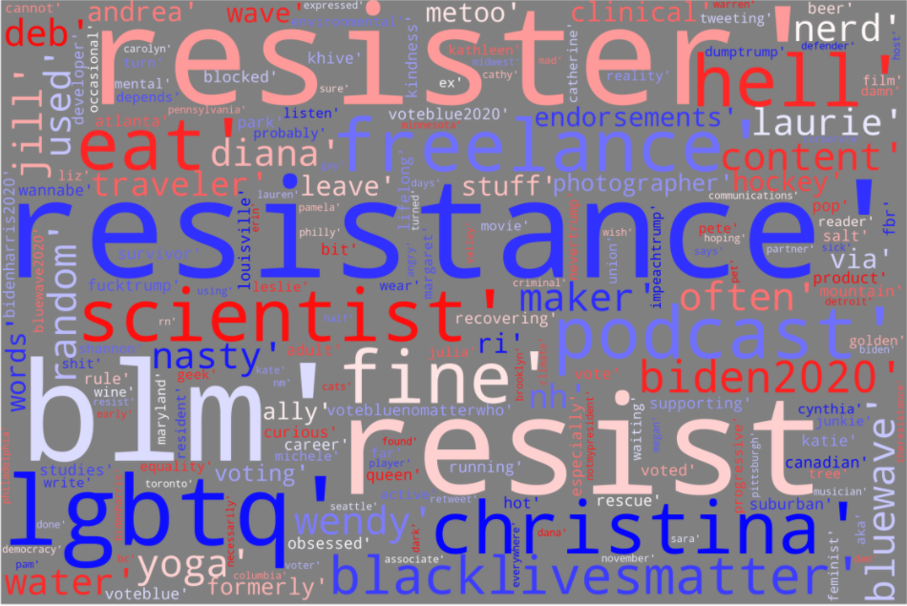  
Figure 1: Wordcloud Amy McGrath’s Followers’ Descriptions Top Words

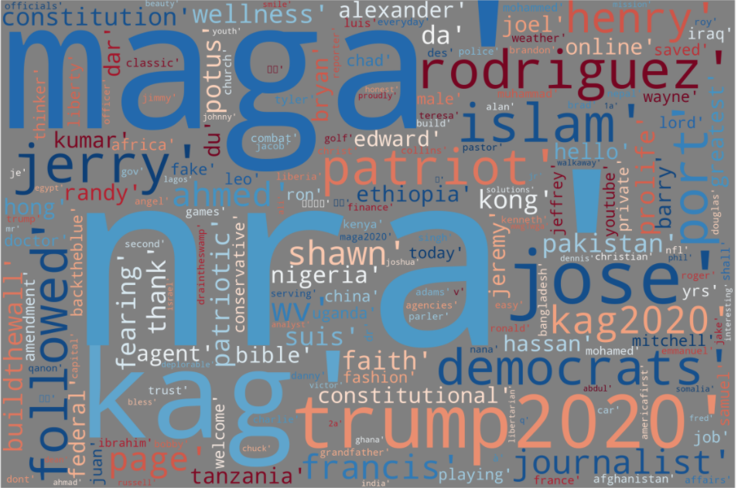  
Figure 2: Wordcloud of Mitch McConnell’s Followers’ Description Top Words

**Resources:**

<https://towardsdatascience.com/simple-wordcloud-in-python-2ae54a9f58e5>

<https://matplotlib.org/3.2.1/tutorials/colors/colormaps.html>